Batch 2: Intermediate Query Explanation
Batch structure: 6 questions
Focus: explaining why a query works, identifying logic, predicting output, and spotting business implications.
Q1 — Explain the Query
Consider:
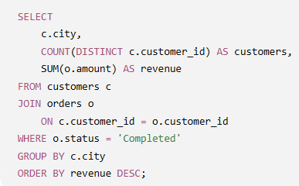
Your task:
Explain this query in your own words.
Cover these 4 points:
- What business question is this query answering?
- Why is JOIN used here?
- Why do we use COUNT(DISTINCT c.customer_id) instead of COUNT(c.customer_id)?
- What does GROUP BY c.city do?
Answer: this is a city-based grouping of customers, counting number of customers per city and city revenue. Revenue is being calculated for only ‘Completed’ order and the output is ordered by revenue is descending order.
- Which cities generates the most revenue and their no. of customers alongside, which cities to focus on to increase revenue, where to gather more customers etc. basically its where to invest and trying to find out why performance is low in some segments/ cities.
- Because data is stored in 2 tables customers and orders, to calculate the city-wise revenue we have to join the 2 tables.
- To find unique customers, avoiding duplication of customers.
- Segments data/rows by city.

Q2 — Your turn
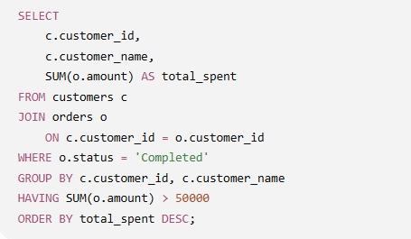
Explain:
- What customers does this query return?
- What is the purpose of the WHERE condition?
- Why can't SUM(o.amount) > 50000 be placed directly inside WHERE?
- What role does HAVING play?
- At what stage is the customer-level total calculated?
Answer: 1 customers who have spent more than 50000 with their completed orders in ordered by revenue in descending order.
2. to filter out completed orders.
3. groups cant be filtered in the where clause
4. filtering groups where total spent is more than 50000.
5. in the select statement itself post the join and where clause filtering.
Q3.
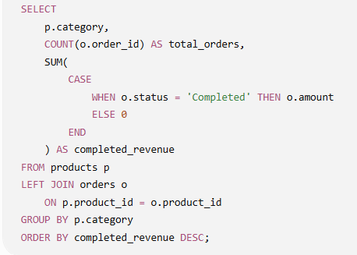

Explain:
- What business analysis is this query performing?
- Why is a LEFT JOIN used instead of an INNER JOIN?
- What does the CASE expression accomplish?
- Why is ELSE 0 important here?
- What happens to a category that has products but no orders?
Answer:
- for each product category, finding the no. of orders and amount generated for completed orders.
- We want to preserve all categories and include then in the final output even they produce nothing, or have no orders from them.
- It applies a condition that sums amount only when the order status is completed.
- If condition fails 0 is added to the total.
- They still show up but no. of orders and amount generated is shown as 0.
Q4.
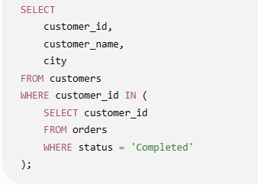
Explain:
- What type of customers are returned?
- What does the inner query produce?
- How does the outer query use that result?
- Why is IN appropriate here?
- What would happen if a customer had only cancelled orders?
Answers:
- Customers who have at least 1 completed order.
- Customer ids from order table where status column reading is ‘Completed’.
- Using only those customer ids that were retrieved from the inner query their names and city along with the customer_id is displayed.
- If customer_id is found within the result of the inner query then only show the asked information in the final output.
- That customer information would not be displayed at all

Q5.
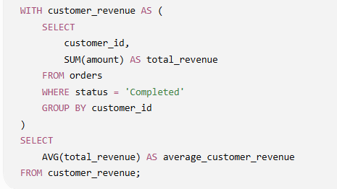
Explain:
- What does the CTE calculate?
- What does one row in customer_revenue represent?
- Why is AVG(total_revenue) calculated in the outer query rather than AVG(amount) directly from orders?
- What business metric is the final query producing?
- What would this metric mean in practical business terms?
Answers:
- It creates a temporary result that has customer_id and their total spending for ‘Completed’ orders.
- Total spend by a customer in ‘Completed’ orders.
- AVG(total_revenue) is the overall average of total spending of all customers separately, that’s why it is not in the cte.
- Total average revenue for completed orders across customers.
- How much on an average a customer is spending on completed orders.
Q6.
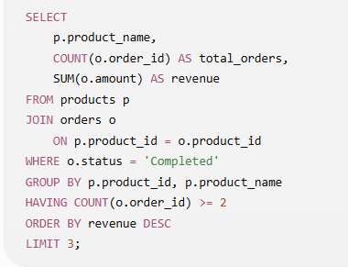
Explain the query from beginning to end.

Cover these 8 points:
- Which tables are involved and how are they connected?
- Which orders are removed by WHERE?
- What happens during GROUP BY?
- What do COUNT() and SUM() calculate?
- What does HAVING filter?
- What does ORDER BY do?
- What does LIMIT 3 ultimately give us?
- What business question does this query answer?
Answers:
- Products and orders tables are joined to generate the asked result, using primary and foreign key concept. Addition condition is added on the where statement.
- Cancelled
- Results are grouped at product level
- Count gives no. of orders, sum give total amount per product for completed orders
- Filters groups which have orders more than one.
- Shows result order by revenue in descending order
- Only 3 rows in the output, or we can say top 3 revenue generating products
- Which products are generating the most completed revenue

